**Supplementary Materials for “Probing Magnetic Properties of Co-Sputtered Co-Tb Alloy Films with Controlled Concentration and Thickness Gradients”**

**Magnetron sputtering chamber**

The magnetron sputtering (MS) chamber used for fabrication of alloy films and multilayers described in the paper is one of the elements of the cluster (PREVAC - Poland) designed for the deposition of layered systems in Ultra High Vacuum conditions (a description of the entire cluster is available in <https://www.ifmpan.poznan.pl/department-of-thin-films/equipment-2020.pdf>). It is equipped with seven flanges for mounting magnetron sources. Two-inch sources (Thin Films Consulting - Germany) have been installed in six of them (Fig. S1). The distance between the centers of adjacent targets is *u* = 130 mm (Fig. 1). The magnetron sources are equipped with computer-controlled shutters and with chimneys to reduce the angular distribution of the sputtered material flux. Moreover, each target can be tilted so that its normal can take arbitrary directions in the plane defined by its center and the main axis of the chamber.

Substrate holders can be placed in two docking stations. The first one is fixed in the central axis of the chamber and equidistant to all sources; it is used to deposit alloy films with compositions regulated by the sources’ individual deposition rates by setting the targets in the confocal configuration. The second docking station, used during the deposition of the films discussed in this paper, is mobile and rests on an arm whose axis of rotation coincides with the central axis of the chamber. The length of this arm is designed so that the distance from the substrate holder to the axis of the chamber is equal to the distance of each target’s center to the same axis. The magnetron sources can be positioned so that all targets lie flat in the plane perpendicular to the chamber’s axis; then, the mobile docking station (carrying the sample holder and substrate) can be placed either directly above individual targets or in intermediate positions for co-sputtering (Fig. 1). Multilayers are fabricated by iteratively switching between these positions and depositing either pure sublayers (above individual targets) or co-sputtered alloys (between two targets). The thickness of individual sublayers can be controlled by their deposition rates (*R*sput) (Fig. S2) and the deposition times (*s*t).

The docking station is also equipped with a motorized shutter placed directly under the substrate (along the Y axis in Fig. 1b). It allows to fabricate wedge-shaped layers on which the thickness gradient is controlled by the deposition rate and shutter’s speed (e.g. Tb/Co multilayers with wedged Tb). Since the distance between the plane of the substrate and the plane of the targets is adjustable (parameter *h,* Fig. 1), the concentration gradient of elements deposited by the co-sputtering can also be controlled. It is also of the utmost importance that we are able to automate the deposition process over a wide set of parameters, such as: sequence of sublayers, sample holder standstill intervals (deposition times), power supplied to individual sources (deposition rates), opening and closing times of magnetron shutter, and movement of the shutter at the docking station.

|  |  |
| --- | --- |
|  | FIGS1b.png |
| **RSY_S1_c.png** |

Fig. S1 Images of magnetron sputtering apparatus. Magnetron sputtering chamber (c) with inner view of bottom (b) and upper (c) part



Fig. S2 Deposition rate (*R*sput) for Tb and Co, as a function of the power (*P*) applied to magnetron sources, measured with a quartz balance placed in the position that the substrate occupies during deposition.

**Target shape**

In magnetron sources, permanent magnets located below a target create a magnetic field, which is responsible for heterogeneous sputtering of the target. To account for this effect in numerical analysis, we have performed calculations for two target shapes: (i) a disc target with radius R and (ii) an annulus target with an inner radius R1 and an outer radius R2 (Fig. S3).

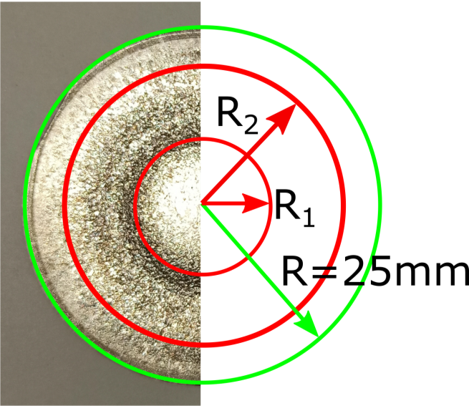

Fig. S3 Target shapes (green disc and red annulus) used in numerical calculations. Left part - photograph of used Co target with visibly higher erosion within the annulus

**Chimney approximation**

Target chimneys prevent part of the sputtered material from reaching the substrate. Therefore, some parts of the target do not contribute to the deposition in given segments of the substrate and should be excluded in calculations (Fig. S4). To that end, we need to find the intersections of the *l*n,k lines connecting points An (target) and Bk (substrate), with the inner surface of the chimney using the parametric equations:

|  |  |  |
| --- | --- | --- |
|  |  |  |

This can be done by solving the general equation for a circle (with center at points *x*0, *y*0) that includes the parametric equation for *x* and *y* from:

|  |  |  |
| --- | --- | --- |
|  |  |  |

The two solutions of the above equation, if they exist, give crossing points of the line with the cylindrical surface containing the defining surface of the chimney:

|  |  |  |  |
| --- | --- | --- | --- |
| where | |  |  |
|  |  | |  |

If the *z*-coordinate of the crossing point is less than 30 mm (chimney height) the given fragment of the target does not contribute to the deposition at Bk.

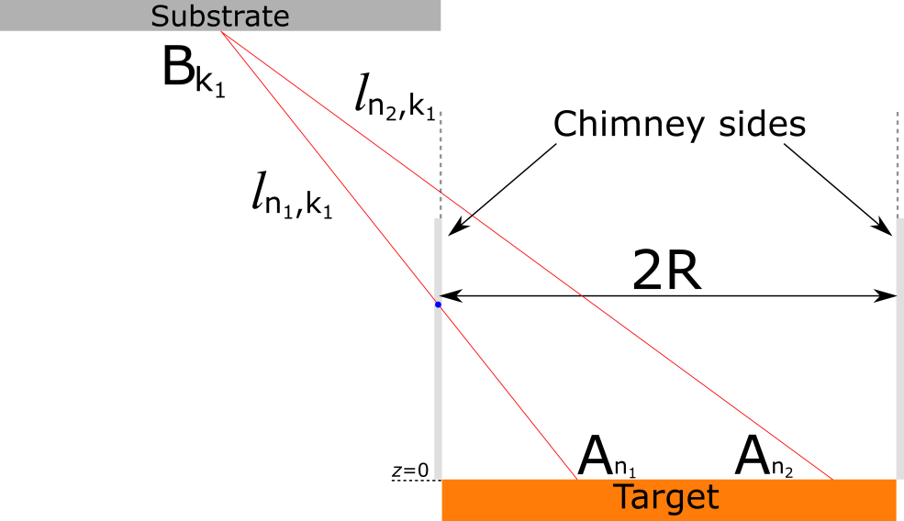

Fig. S4 Schematic of the chimney blocking part of the material flux during the sputtering process. For Bk1 point on the substrate, An1 point in target will be excluded from the sum, because line *l*n1,k1 intersects the chimney (blue dot)

**Deposition profile used for calculations presented in Fig. 3 in the main text of the paper**



**Fig. S5.** Deposition profile (*G*) as a function of distance from the center of the target (*ρ*) for the two distances between the plane of the targets and the substrate (*h*) with and without the chimneys for circular (a) and annulus (b) targets.

**Thickness, concentration and coercive fields (*H*C) profiles of Co-Tb co-sputtered alloy films deposited at the distance between targets and substrate planes h = 147 mm**

In the main text we discuss the results for Co-Tb films deposited at *h* = 97 mm. Here we show the analogous calculation and experimental results for the Co-Tb sample deposited at *h* = 147 mm.

Calculation of thickness (*t*Tb-Co) and Tb concentration (*c*Tb) distribution for Co-Tb film deposited at *h* = 147 mm for the two shapes of the target are presented in Fig. S6 and Fig. S7, respectively.

|  |  |
| --- | --- |
|  |  |

Fig. S6 Calculated maps of the thickness of the Tb-Co alloy films as a function of the location on the substrate (and relative to Tb target axis **Tb) for *h* = 147 mm (a) annulus and (b) disc targets

|  |  |
| --- | --- |
|  |  |

Fig. S7 Calculated maps of the Tb concentration distribution of (*c*Tb) as a function of the location on the substrate for *h* = 147 mm for the TbxCo100-x alloy for (a) annulus and (b) circular targets

The results presented in Fig. S6 and Fig. S7 confirm that for larger *h* the ∂*t*Co-Tb/∂X and ∂*c*Tb/∂X gradients are both smaller. They also show that the specific target shape has negligible influence on *t*Co-Tb and *c*Tb profiles.

To validate our calculation, as was done for sample deposited at *h* = 97 mm (Fig.4c in the main text), we measured the spatial dependence of *c*Tb (Fig. S8a). In Fig. S7b the experimental results are directly compared with numerical calculations performed for both target shapes.

|  |  |
| --- | --- |
|  |  |

Fig. S8 (a) Maps of Tb concentration (*c*Tb) of Tb-Co alloy films deposited at the distance between the targets and substrate plane *h* = 147 mm. The *c*Tb values determined from the SEM-EDS measurements. (b) *c*Tb profiles together with the fit using the numerical model (solid line) for the disc and annular targets

The map of *H*C values (determined from local P-MOKE hysteresis loops) for Co-Tb film deposited at *h*= 147 mm is presented in Fig. S9a. In Fig. S9b the results obtained for the alloy film are compared with those measured for Co/Tb multilayer.

|  |  |
| --- | --- |
|  |  |

Fig. S9 (a) Map of the coercive field (*H*C) determined from magneto-optical hysteresis loops of Tb-Co alloy film deposited at *h* = 147 mm. (b) *H*C(*c*Tb) for the alloy film and for the (Tb-wedge-0-2nm/Co-0.66 nm)6 multilayer

Squareness (*φ*R/*φ*S) and Kerr signal (*φ*R) of hysteresis loops as a function of *c*Tbfor both samples are shown in Fig. S10. Results are obtained along the line Y = 0.

|  |  |
| --- | --- |
|  |  |

Fig. S10 Kerr signal (*φ*R) and ratio of the Kerr signals in remanence and saturation (*φ*R/*φ*S) as a function of Tb concentration (*c*Tb) for Tb-Co alloys deposited at two distances between the plane of the targets and the substrate (a) *h* = 147 mm and (b) *h* = 97 mm